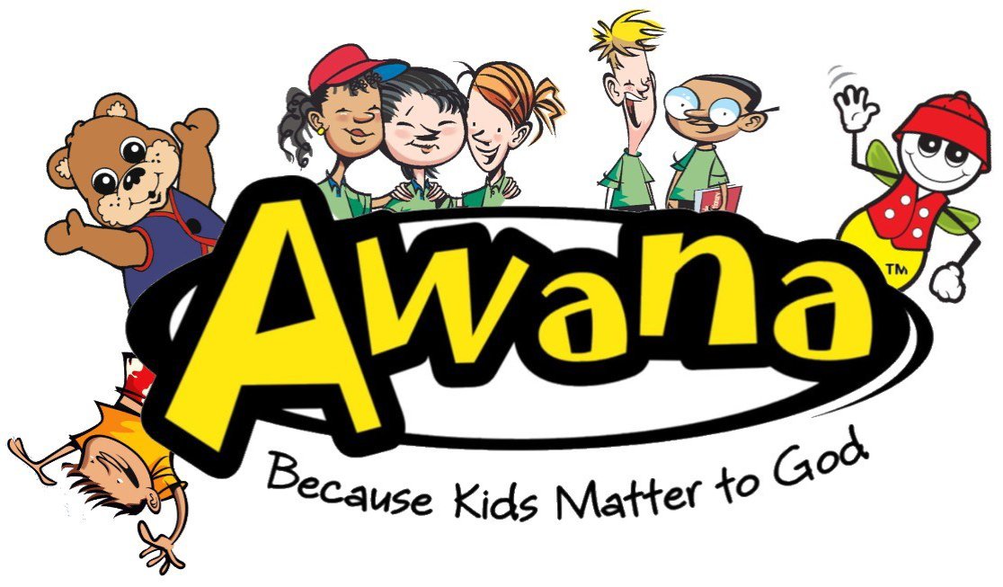

**South Holly Church**

**AWANA Club Handbook**

**Club Year 2024-2025**

“Do your best to present yourself to God as one approved, a worker who has no need to be ashamed, rightly handling the word of truth.” 2 Timothy 2:15 (ESV)



**Welcome to AWANA**

Thank you for your interest in AWANA. We believe that there is no greater calling than being the hands and feet of Jesus to children. At AWANA, clubbers will learn God’s Word and grow in their knowledge of Him while developing meaningful relationships with others. This handbook is intended to keep parents and guardians informed by communicating the most important aspects and details of the AWANA ministry.

**About South Holly**

South Holly Church is built around the idea of practicing the way of Jesus, together, in our city. We believe that to be an apprentice of Jesus is to order your life around three goals:

**Be** with Jesus, **Become** like Jesus, and **Do** what Jesus did.

Our dream is that as we live this way, our lives, our communities, and our city, will be transformed by the power of Jesus in and through His people. We believe the Church is not another sub-culture, but the making of a new humanity. It’s not a building or a weekend activity, but a people. We strive to live out the Gospel in our city throughout the week, then gather each weekend as a collection of Communities. We want to partner with God in his relentless pursuit of people. Our prayer is as Jesus prayed, that God’s will would be done in our city as it is in Heaven, and that as the Church becomes One as the Father, Son and Spirit are One, the Truth of salvation will spread in and through God’s people.

**AWANA Principles**

AWANA has been around since 1950 and has grown from a ministry in one church to a ministry that now takes place in over 30,000 churches in 100 countries worldwide reaching over 3 million students each week. AWANA exists to reach children everywhere with the gospel of Jesus Christ and engage them in lifelong discipleship. The AWANA prayer is that children and youth throughout the world will come to know, love, and serve Jesus Christ.

**2024-2025 AWANA Theme**

*Ohana Means Family*

I John 3:1: How great is the love the Father has lavished on us, that we should be called children of God!

**Club Details**

AWANA club will meet each Sunday evening beginning on Sunday, August 18, 2024, through Sunday, April 27, 2025, from 3:00-4:30 PM at South Holly Church. Clubs are available for children ages 3-12th grade.

October

**Club Structure**

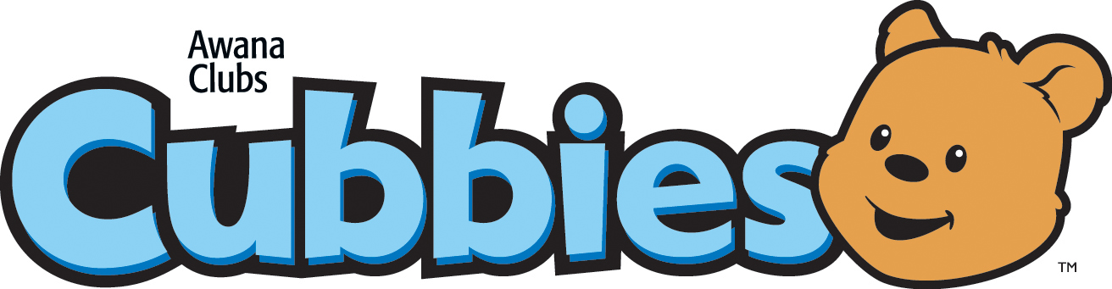 Preschool (ages 3-4)

 Kindergarten-2nd Grade

 3rd – 6th Grade

 7th – 8th Grade

journey-logo.png 9th - 12th Grade

**SECURITY & CHILD PROTECTION**

At South Holly Church, the safety and security of children is of utmost importance to us. Some of our procedures may seem inconvenient, but our priority is taking care of each precious child entrusted to our care.

For safety reasons, we encourage parents to drop off and pick up their own child(ren) inside each week. If a different person other than a parent is picking up the child(ren), please let your child(ren)’s leader or director know. Certain doors will not be accessible during club night, so be sure that you are early (or on time) for drop-off and pick up.

Our trained volunteer leaders and directors have been screened, including background and reference checks to ensure the safety of your child(ren). For further information about our policies, please speak with Sean or Jaime Larson or Pastor Shannon Popp.

**Parent Expectations**

Parents should understand what is required each week and encourage their child(ren) to complete sections and study scripture on an ongoing basis. The more involved a parent is, the more likely a child is to succeed and enjoy handbook time. Challenge yourself to memorize scripture also. By memorizing scripture along with your child(ren), you are providing encouragement as you work toward the same goal!

Parents should notify the AWANA leadership of any special needs, allergies, or physical restrictions that your child(ren) may have.

We encourage parents to attend all special events to celebrate and acknowledge the clubbers’ hard work and accomplishments!

**Student (Clubbers) Expectations**

Clubbers should be respectful of leaders, peers, and church property.

Clubbers are expected to be on time and make sure to check-in with the AWANA Secretary. Failing to do so could result in losing perfect attendance.

Clubbers are expected to stay with their assigned class.

Clubbers are expected to wear a clean, tidy uniform each week.

Clubbers are expected to bring their handbook and Bible each week.

**Annual Cost**

As a member of the AWANA club, each student will receive a handbook and uniform upon completion of their two-week introduction booklet. Students also receive awards for their accomplishments through the year. These items have a cost associated with them and will be offset by the $75/year dues (including uniform). This is an annual cost and should be paid during initial registration. If initial handbooks or uniforms are lost, parents will be responsible for purchasing replacements.

Families experiencing financial hardship and cannot pay the annual fee, should discuss this with the club Director or Secretary. We never want to turn away a student due to financial reasons.

**Cubbies Club**

Cubbies Handbook $15.00

Cubbies T-shirt $17.00

AWANA Canvas Bag $14.00

**Sparks Club**

Sparks Handbook $15.00

Sparks T-shirt $17.00

AWANA Canvas Bag $14.00

Sparks Extra Credit Frequent Flyer Handbook $14.00

**Truth & Training Club**

T & T Handbook $15.00

T & T Uniform Shirt $17.00

AWANA Canvas Bag $14.00

**Trek Club**

Trek Bible Study $16.00

Trek T shirt $17.00

AWANA Canvas Bag $14.00

**Journey Club**

Journey Bible Study $22.00

Journey T shirt $17.00

AWANA Canvas Bag $14.00

**Uniform Guidelines**

Clubbers are expected to wear their uniforms to club each week as well as any special AWANA events. Awards will be placed on an AWANA sash that will remain at club until the end of year.

Clubbers should wear closed toe shoes each week to ensure safety at game time. No flip flops or sandals. Girls wearing skirts are encouraged to have leggings or shorts on underneath their skirt.

**AWANA Schedule**

Reaching boys and girls with the Gospel of Christ and training them to serve Him is our two-fold purpose. We strive to accomplish our purpose through three main elements:

Large Group Time: Begins each Sunday night at 3:00 PM with pledges, AWANA theme song, club verse, opening prayer, and announcements. The students will say the pledge to the United States and AWANA flags. Students will sit on the AWANA game square by assigned clubs.

**Pledge to the United States Flag**

I pledge allegiance to the Flag

of the United States of America;

and to the Republic for which it stands,

one Nation under God, indivisible,

with liberty and justice for all.

**Pledge to the AWANA Flag**

I pledge allegiance to the AWANA flag

which stands for the AWANA clubs

whose goal it is to reach boys and girls

with the Gospel of Christ

and train them to serve Him.

**AWANA Theme Song**

Firmly AWANA stands, led by the Lord’s Commands, “Approved workmen are not ashamed,”

Boys and girls for His service claimed!

Hail! AWANA! On the march for youth;

Hail! AWANA! Holding fourth the truth.

Building lives on the Word of God AWANA stands!

Our Savior following with steps unfaltering,

And love unaltering, His praise we sing.

His banner over us, in service glorious,

We’ll fight victorious for Christ our King!

**YOUTH ON THE MARCH!**

**Club Scripture**

“Do your best to present yourself to God as one approved, a worker who has no need to be ashamed, rightly handling the word of truth.”

2 Timothy 2:15 (ESV)

Small Group Time: Clubbers work in a group or one-on-one with a trained leader to complete sections in their handbook. Some sections have items that need to be completed at home. AWANA emphasizes the memorization and understanding of key Bible verses that show how to know God and walk with Him. A series of awards and trophies are given for achievements at every level as clubbers progress. The clubbers will hear a message from God’s Word presented by their leader. Depending on the age group, crafts may also be completed.

Game Time: Individual and team competitions take place through games via the AWANA circle, inside, or outside areas.

**AWANA Section Standards**

Our goal at AWANA is to have clubbers memorize God’s Word, allow it to shape their minds and hearts, and cause them to live their lives differently as a result. To ensure kids are learning the scriptures and providing consistency for all clubbers, the following standards will be followed when signing off on handbook sections. The handbooks provide spaces for parents to sign off on sections. By doing this, it will allow your child(ren) to earn extra AWANA bucks.

Clubbers move through their handbooks together as a group. Handbooks are designed to be finished in the AWANA club year. Each handbook typically has 32 sections to complete. Children should work on sections during breaks (fall, winter, and spring) so that they can stay on track. Extra credit material is available for those who want an additional challenge!

Scripture should be memorized using the English Standard Version (ESV) in the student handbook.

All parts of the section should be completed in one sitting including verses, questions, and activities.

No more than two helps will be given per section. Helps can be verbal, hand motions, or facial gestures.

Clubbers must recite the Bible reference before saying the verse and then again after the verse. (Example: Romans 3:23 “For all have sinned and fall short of the glory of God.” Romans 3:23). It is so important to know the reference so they can locate it in the Bible.

Sections should be completed in order, unless otherwise noted.

Parents should explain the meaning of each verse. You will find that your child(ren) will memorize more quickly if they understand what they are memorizing. If you want to confirm the meaning, there are “help” sections in the handbook or a digital download which comes with each book. Your child(ren)’s leader is also available to assist you with any questions you may have.

Sections are passed when recited to an AWANA leader during club or when special arrangements are made by the leader. Leaders should not listen and sign off on sections for their own child(ren).

**AWANA Bucks**

In addition to awards that clubbers can earn for their uniforms, Cubbies, Sparks and T&T students can earn AWANA bucks to spend at the AWANA store. AWANA Store nights for the 2024-2025 calendar year will be: January 5, 2025 & April 27, 2025.

AWANA bucks must be used within the club year. T&T clubbers will receive physical paper bucks. The AWANA Secretary will keep AWANA bucks for the Cubbies, Sparks, & T&T. Trek and Journey will receive gift cards in lieu of AWANA bucks.

**Club Cancellation**

In the event of inclement weather or forecasted inclement weather, club cancellation will be announced via email, text, or phone call. We love AWANA and DISLIKE cancelling. As ALWAYS, parents should make the final decision about whether they can safely make it to club.

**Other South Holly Church Programs & Services**

If you do not have a home church, we would love for you to join us at South Holly. For more information, please visit our website at:

<https://southholly.org>

**Thank you for reviewing this handbook. If you have any questions during the year, please feel free to contact:**

Sean and Jaime Larson, AWANA Co-Commanders

Cell: (951) 283-1253

South Holly Church: (303) 773-1717

AWANA Commander’s Email: [seanjaime1@yahoo.com](mailto:seanjaime1@yahoo.com)

South Holly Church Email: [office@southholly.org](mailto:office@southholly.org)

**Theme Nights**

Theme nights add fun, competition, and provide a way for clubbers to earn extra AWANA bucks. Some nights involve participation from home (dressing up, bringing a friend, etc.) while others are fun themes that will be integrated into the club night. Our club Secretary will send an email each week to remind parents and clubbers of the weekly theme. Theme night participation is optional; but strongly encouraged. Theme nights will not be made up in the event of club cancellation. Below is a list of all 2024-2025 theme nights:

08.18.24:        **Ohana Means Family Night**

Come and enjoy opening night with your kids. We will sample

Hawaiian snacks, work on entrance booklets, and have family

game time.

08.25.24: **Wet n Wild Rain Gutter Regatta Night**

Wear something to get wet in as well as bring a change of

clothes, towel, flip flops, waterproof bag, water gun, or other

water toys for outside play. Kids will race their boats and

compete for prizes.

09.01.24:             **No AWANA – Labor Day**

09.08.24:             **Funky Fest:  Make a Joyful Noise Night**

A special speaker will be sharing their musical talents during

club time.

09.15.24:             **Backpack Packrat Night**

How many things can you cram into your backpack? Stuff it

with as many things as possible. We will have a backpack scavenger hunt during game time to see who can match the most items to Mr. Sean’s backpack.

09.22.24:             **Mad Scientist Night**

Come experiment with us as we explore the fascinating world

of science.

09.29.24:    **Free the Feet Night**

Decorate your feet and come to compete. Who will win the prize for the most outrageously decorated feet?

10.06.24:             **“Popp”arazzi Night – Larson Family on Vacation**

Enjoy an exciting night with Pastor Shannan as he “pops” all through our club time. Of course, there will be plenty of popcorn to eat and play with during our game time.

10.13.24:             **No AWANA-Fall Break**

10.20.24: **Blues Night**

How much blue can you wear or put on your body? Let’s

find out. Prizes will be awarded for the best in each club.

10.27.24:             **Great Pumpkin Night**

No need to wait until Halloween to wear your costume. No costume, no problem…see how much orange you can wear. Let’s have a spooktacular time!

11.03.24:             **Put it In Reverse Night**

Let’s back it up for the night by wearing our clothes

backwards, entering club backwards, and experiencing our club from end to beginning.

11.10.24:             **Rucksack Rebel Night**

Rucksacks, cammo, uniforms, MRE’s, obstacle course…what do all of these have in common? Join us for military appreciation night by wearing red, white, and blue to enter our raffle. There will be a very special guest speaker joining us for club that evening.

11.17.24:             **AWANA on Mission Night**

Joe and Jill Cook our AWANA missionaries will be our special

guests. The mission’s collection in November will be presented to the Cook’s during club. Kids will participate in a service project during game time.

11.24.24:             **No AWANA:  Thanksgiving**

12.01.24:             **Quiet as a Mouse Night**

Is it even possible? Whispering and hand gestures will be the mode of communication for the evening.

12.08.24:             **Mystery Night**

This is such a mystery we are still trying to figure it out. Let’s see if you can figure out the clues!

12.15.24: **Happy Birthday Jesus Night**

Join us as we celebrate Jesus’ birth. Come dressed in

your favorite Christmas Pajamas.

12.22.24:             **No AWANA:  Christmas – Winter Break**

12:29.24:             **No AWANA:  New Year – Winter Break**

01.05.24:             **Ice to See You Night – AWANA Store**

Let’s see how many layers you can wear to our AWANA winter wonderland. Ice games, snowball fights, frozen treats. Can you survive the cold?

01.12.25:             **Glow for God Night**

How bright we can shine for Jesus? Wear your

brightest neon or fluorescent colors and bring a flashlight. Club will be conducted in the dark and there will be a special glowing game time!

01.19.25:             **Go Big or Go Home Night**

Even Goliath would have a hard time navigating big game time. Let’s see who can conquer and take home the victory.

01.26.25:             **Inside Out Night**

Let’s bring the outside in as we set up camp indoors and

enjoy tents, hotdogs, smores, and camping bingo! Make sure to wear your clothes inside out for the evening!

02.02.25:             **Whose Got Game Night**

Helen Keller said, “Alone we can do so little, together we can do so much”. We will put that to the test tonight as kids learn to work together toward a common goal. Wear your favorite sports jersey to enter the raffle.

02.09.25:             **No AWANA:  Super Bowl**

02.16.25:             **Fundue Night**

Chocolate fondue is so much Fundue. Kids will enjoy a special treat during game time as we see how many things we can find to dip in chocolate. Leaders will incorporate chocolate into handbook and game times also.

02.23.25:             **Survival Night**

What does it take to survive? Come to club and see! Proactive preparation is the theme for the night.

03.02.25:             **Lights, Camera, Action Night**

Wear your favorite PJ’s and bring your favorite sleeping bag or

blanket as we enjoy Lilo and Stitch and of course some treats!

03.09.25:             **Record Breaker Night**

Come prepared to compete and see if you can get your name

entered into the AWANA book of world records!

03.16.25:             **No AWANA-Spring Break**

03.23.25:             **Minute to Win It Night**

Fast and Furious is the speed for our game time!

03.30.25: **Fabulous Food Night**

Come hungry as the entire club night will be centered around

food.

04.06.25: **Verse-a-Thon Night**

Gather those pledges and learn those verses to help support

AWANA ministries abroad.

04.13.25:             **Eggstravagant Easter Excitement Night**

There is nothing more exciting than sharing the Easter Story

with our kids. There will be plenty of Easter Excitement all through the night.

04.20.25:             **No AWANA: Easter Break**

04.27.25:             **Aloha Night – AWANA Store**

We can’t believe it is time to say goodbye☹ Come dressed in your favorite Hawaiian attire as we close out our club year.

05.03.25:             **AWANA Awards & End of Year Celebration**

Parents and friends, join us as we celebrate the

accomplishments of our children.